28.32: Consider a coaxial cable where the currents run in OPPOSITE directions.
a) For 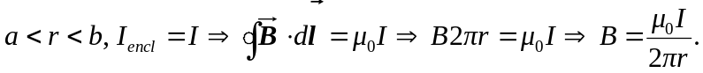
b) For 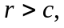 the enclosed current is zero, so the magnetic field is also zero.

